**ABSTRACT**

**ABSTRACT**

The project is a web application that was created with the Flask framework. TensorFlow was used for machine learning tasks while OpenCV was used to recognise face emotions. To authenticate users and collect their information (email, password, phone number, first and last name), the application comprises of a login and signup page.After their login is successful, users are taken to a dashboard page. OpenCV is used by the dashboard to identify a variety of facial emotions, such as "Neutral," "Happy," "Sad," "Disgust," "Fear," and "Angry." The application makes song,age and gender recommendations based on the emotion it has identified in the user.For machine learning and computer vision tasks, the application's backend makes use of the TensorFlow and OpenCV libraries, respectively. TensorFlow's Keras API is used to load the facial emotion detection model, and OpenCV is used to capture and evaluate face photos in real-time.Furthermore, MySQL is used in the project for database management, enabling safe user data storage. By enabling real-time communication between the client and server, Flask-SocketIO improves user experience through dynamic updates.All things considered, the idea combines a number of different technologies to produce an interactive online application that suggests films to users based on their facial expressions.

**INTRODUCTION**

* **INTRODUCTION**

Web applications are essential in today's digital world for giving users personalised experiences. These website may now provide personalised recommendations and services based on user behaviour and preferences thanks to the development of cutting-edge technologies like facial recognition and machine learning. Here, we present a brand-new Flask framework-based web application that combines TensorFlow for machine learning tasks with OpenCV for facial emotion recognition.

* **PROJECT OVERVIEW**

The project is a dynamic online application that uses personalised song ,age and gender suggestions and face emotion recognition to provide for a fun and interesting user experience. The application, which was created with Flask, OpenCV, TensorFlow, and MySQL, provides users with a smooth interface for logging in, supplying personal data, and interacting with real-time emotion analysis and song ,age and gender recommendations.The application's main screen is where users authenticate themselves and enter basic information such email addresses, passwords, and contact details. A MySQL database is used to securely store this data, guaranteeing both data integrity and user privacy.Users are taken to a dashboard where the magic happens after logging in. The programme uses OpenCV's ability to analyse users' facial expressions in real-time and recognise emotions like surprise, happiness, sadness, and anger..

The application's TensorFlow-powered song ,age and gender recommendation engine is truly its best feature. The application creates personalised song ,age and gender recommendations based on user preferences, song ,age and gender metadata, and facial emotion data that align with the user's interests and mood. The software makes recommendations for song ,age and gender based on users' emotions, so they can watch song ,age and gender that will make them feel happy, thoughtful, or daring.

The application makes use of Flask-SocketIO, which allows bidirectional communication between the client and server, to provide smooth communication and real-time changes. This guarantees seamless navigation and interactive elements, enabling viewers to easily browse suggested films and get real-time sentiment updates.

* **OBJECTIVE OF THE PROJECT**

The project's goal is to create a web application that makes personalised song ,age and gender suggestions by using machine learning and face emotion recognition. The application attempts to precisely determine users' emotional states by analysing their facial expressions in real-time. By utilising emotional data in conjunction with user preferences and song ,age and gender metadata, the system produces personalised song ,age and gender recommendations that correspond with users' interests and moods. Furthermore, the project seeks to guarantee a flawless user experience by means of safe authentication, effective data storage, and instantaneous communication, thereby augmenting user involvement and contentment with the platform.

**SYSTEM SPECIFICATION**

**2. SYSTEM SPECIFICATION**

**2.1 HARDWARE SPECIFICATIONS**

The below Hardware Specifications were used in both Server and Client machines when developing.

**Processor :** AMD PRO A4-4350B R4, 5 COMPUTE CORES 2C+3G

2.50 GHz

**RAM :** 4GB

**Hard disk** **:** 256GB

**System type :** x64-based processor

**2.2 SOFTWARE SPECIFICATIONS**

The below Software Specifications were used in the machines when developing.

**Operating system :** windows 10

**Frontend :** HTML, CSS, Javascript

**Backend :** PYTHON

**Framework :** FLASK

**Database :** MYSQL

**Database Connectivity** : XAMPP Server

**Machine Learning** : Tensorflow

* **MACHINE LEARNING:**

TensorFlow serves as a powerful machine learning framework utilized to train and deploy models for facial emotion recognition. TensorFlow provides a comprehensive ecosystem of tools and resources for developing and executing machine learning algorithms efficiently. Specifically, in this project, TensorFlow is employed to create and train deep learning models capable of recognizing facial expressions accurately in real-time. TensorFlow's deep learning capabilities enable the creation of sophisticated neural network architectures, such as convolutional neural networks (CNNs), which excel at processing and analyzing image data. These models can be trained using labeled datasets containing images of facial expressions, allowing them to learn patterns and features associated with different emotions.

Once trained, the TensorFlow models are integrated into the project to perform real-time facial emotion recognition. This involves capturing facial images using a camera module, preprocessing the images to extract relevant features, and feeding them into the trained model for inference. The model then predicts the emotion expressed in the facial image, which is subsequently used to personalize song ,age and gender recommendations based on the user's mood.

**2.2.2 HTML:**

HTML stands for **“Hyper Text Markup Language”**, which is the most widely used language on Web to develop web pages.

HTML was developed with the intent of defining the structure of documents like headings, paragraphs, lists, and so forth to facilitate the sharing of scientific information between researchers. Now, HTML is being widely used to format web pages with the help of different tags available in HTML language.

* **CSS:**

CSS (Cascading Style Sheet) is used to control the style of a web document in a simple and easy way. is a simple design language intended to simplify the process of making web pages presentable.

CSS is a must for students and working professionals to become a great Software Engineer specially when they are working in Web Development Domain. some of the key advantages CSS are:

* **Create Stunning Web site** - CSS handles the look and feel part of a web page. Using CSS, you can control the color of the text, the style of fonts, the spacing between paragraphs, how columns are sized and laid out, what background images or colors are used, layout designs,variations in display for different devices and screen sizes as well as a variety of other effects.
* **Become a web designer** - If you want to start a carrer as a professional web designer, HTML and CSS designing is a must skill.
* **Control web** - CSS is easy to learn and understand but it provides powerful control over the presentation of an HTML document. Most commonly, CSS is combined with the markup languages HTML or XHTML.
* **Learn other languages** - Once you understands the basic of HTML and CSS then other related technologies like javascript, php, or angular are become easier to understand.
* **PYTHON:**

Python is a high-level, interpreted programming language known for its simplicity, readability, and versatility. Guido van Rossum initiated its development in the late 1980s, and it has since evolved into a widely-used language in various domains.

* **Interpreted Language**: Python is an interpreted language, meaning that its code is executed line by line by the Python interpreter, eliminating the need for compilation before execution.
* **Readability and Simplicity**: One of Python's key strengths is its emphasis on readability, achieved through clear and expressive syntax. This simplicity enhances the development and maintenance of Python code.
* **Multiparadigm Programming:** Python supports multiple programming paradigms, including procedural, object-oriented, and functional programming, allowing developers to choose the approach that best suits their needs.
* **Extensive Standard Library**: Python comes with a comprehensive standard library, offering modules and packages that facilitate various functionalities such as file handling, networking, and database access.
* **Cross-Platform Compatibility:** Python is a cross-platform language, meaning that Python code can run on different operating systems without modification, contributing to its portability.
* **Large and Active Community:** Python has a large and active community of developers who contribute to its growth. This community support, coupled with extensive documentation, makes Python accessible to both beginners and experienced programmers.
* **Wide Range of Applications:** Python is employed in diverse applications, including web development, data science, artificial intelligence, machine learning, automation, and scripting.
* **MY-SQL:**

MySQL, the world's second-most-popular open-source database, plays a crucial role in powering major applications like Facebook, Twitter, Netflix, Uber, Airbnb, Shopify, and Booking.com. With over 25 years of collaborative development, MySQL supports a wide range of applications and programming languages.

As an open-source database, MySQL offers extensive features and broad compatibility with various applications and programming languages. Its popularity is evident in its widespread use, supporting favorite applications and programming languages across diverse domains.

Databases serve as essential data repositories for software applications, storing information from web searches, logins, transactions, and more. MySQL, being a relational database, organizes data into separate tables, optimizing speed and offering a flexible programming environment. The Structured Query Language (SQL) is integral to MySQL, providing a standardized language for database access.

MySQL's open-source nature allows users to download and use the software without cost, with the added benefit of modifying the source code to suit specific needs. Governed by the GNU General Public License (GPL), MySQL consistently ranks as the preferred database for developers due to its high performance, reliability, and ease of use.

This database is the top choice for renowned open-source applications like WordPress, Drupal, Joomla, and Magento, and it forms a key component in the LAMP stack (Linux, Apache, MySQL, Perl/Python/PHP) for web application development.

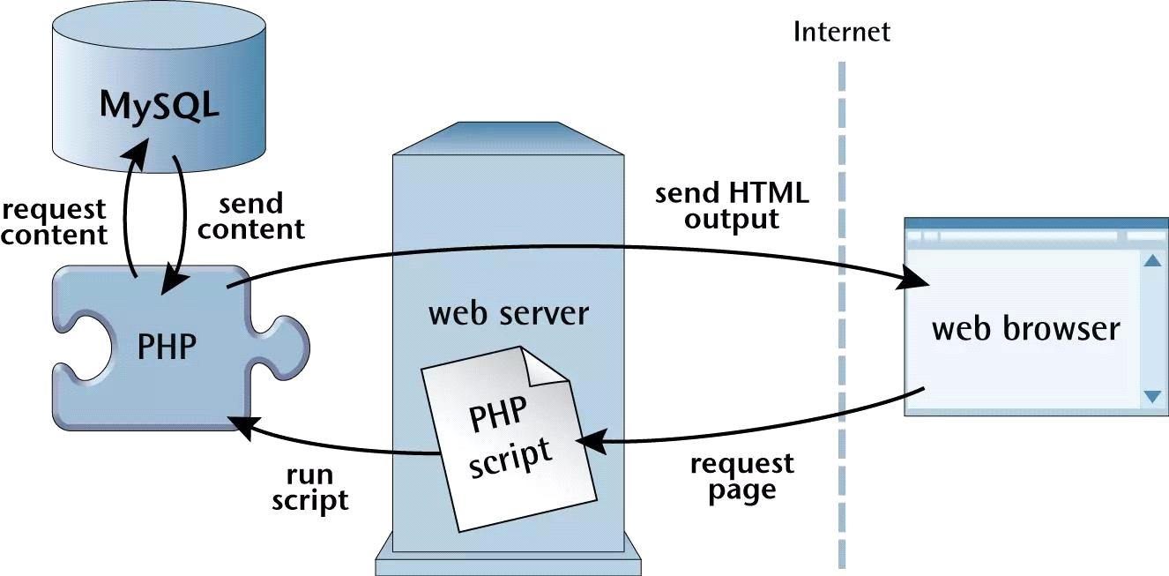

* **DESCRIPTION**
* Flask Application
* Database Management
* OpenCV Integration
* TensorFlow Model
* Song ,age and gender Recommendation
* Frontend Development
* Integration and Deployment
* **Flask Application**

The Flask Application module serves as the backbone of the web application, responsible for managing HTTP requests and responses, rendering web pages, and handling user sessions. It encompasses routes dedicated to the login and signup pages, as well as the dashboard and other essential functionalities. Leveraging Flask's render_template function, it seamlessly integrates HTML templates into the application's structure, providing a dynamic and interactive user interface. Moreover, Flask's request object enables access to form data, facilitating user input validation and processing. Crucially, the module employs Flask's session object to manage user sessions, ensuring secure authentication and persistent user states throughout their interactions with the application. This comprehensive approach to web development with Flask ensures smooth navigation, robust user authentication, and efficient session management, enhancing the overall user experience.

* **Database Management**

The Database Management module facilitates smooth interactions for saving and retrieving user information by acting as a link between the web application and the MySQL database. This module ensures dependable data transmission by creating secure connections to the database using the MySQL Connector/Python package. Inserting new user records at signup and verifying user credentials during login are among its fundamental features. By use of carefully designed features, the module manages the registration process's entry of user data into the database, ensuring that the data is accurate and complete. Furthermore, it is essential to the authentication process since it validates user credentials during login and compares the correctness of login information to database records that are saved. This strong database administration strategy guarantees safe user authentication, effective data processing, and smooth integration that promotes a simplified user experience with the online application.

* **OpenCV Integration:**

The OpenCV Integration module is pivotal for enabling facial emotion recognition within the web application. By seamlessly integrating OpenCV, it harnesses the robust computer vision capabilities of the library to capture and process facial images in real-time. This functionality is essential for accurately detecting facial landmarks, extracting pertinent facial features, and ultimately recognizing emotions based on facial expressions. Through meticulously crafted functions, the module facilitates the detection of key facial landmarks such as eyes, nose, and mouth, enabling precise extraction of facial features. Leveraging these features, the module employs sophisticated algorithms to analyze facial expressions and infer underlying emotions. By encapsulating these functionalities, the OpenCV Integration module ensures seamless integration of facial emotion recognition capabilities into the web application, thereby enhancing user engagement and interactivity.

* **TensorFlow Model :**

The TensorFlow Model module plays a pivotal role in the project by leveraging a pre-trained TensorFlow model for facial emotion recognition. Utilizing TensorFlow's Keras API, the module seamlessly loads the pre-trained model, providing a robust foundation for accurate emotion recognition. Its core functionalities encompass preprocessing facial images and performing inference to predict the emotion expressed in the images. Through meticulously crafted functions, the module preprocesses facial images to extract relevant features and standardize inputs for the model. Subsequently, leveraging the loaded model, it conducts inference to predict the emotion expressed in the images with high precision. By encapsulating these functionalities, the TensorFlow Model module ensures efficient integration of deep learning capabilities into the project, enabling accurate and real-time facial emotion recognition.

* **Song, age and gender Recommendation:**

The Song age and gender Recommendation module is instrumental in enhancing user experience by generating personalized Song age and gender suggestions based on the user's emotional state. Employing a combination of machine learning techniques or predefined rules, the module intelligently matches user emotions with suitable song ,age and gender based on genres or titles. This process involves analyzing the user's facial expression data, captured through facial emotion recognition, and correlating it with a database of song ,age and gender categorized by genre, mood, and other attributes. By meticulously designed functions, the module queries a song ,age and gender dataset or API to retrieve relevant song ,age and gender recommendations tailored to the user's emotional state. Through this approach, the module enhances user engagement by providing curated selections aligned with their current mood, preferences, and interests, thereby enriching their overall viewing experience.

* **Frontend Development :**

The Frontend Development module is dedicated to crafting the user-facing components of the web application, employing HTML, CSS, and JavaScript to create an intuitive and visually appealing interface. Central to its role is the design and implementation of essential pages such as the login and signup interfaces, as well as the dashboard and other user interface elements. By leveraging HTML and CSS, the module ensures seamless layout and styling, providing users with an aesthetically pleasing experience. Furthermore, it harnesses the power of JavaScript to enhance user interactions, facilitating client-side interactions and implementing form validations to ensure data integrity and enhance user experience. Through meticulous attention to detail and user-centric design principles, the Frontend Development module contributes to a cohesive and engaging user interface that enhances overall usability and satisfaction.

* **Integration and Deployment:**

The Integration and Deployment module completes the process of integrating the full web application and enabling user access. It manages the smooth integration of every element, guaranteeing that various modules efficiently exchange information with one another. This module makes sure that the web application is hosted on a web server and made accessible to users via the internet by managing the deployment process. The Flask application and MySQL database are hosted by technologies such as XAMPP or other comparable solutions, which offer a stable and expandable infrastructure necessary for the programme's seamless operation. The Integration and Deployment module ensures a flawless user experience by means of rigorous testing and optimisation, enabling users to access the web application with ease and take use of its functions without any interruptions.

* **Data collection**
* **Data Preprocessing**
* **Feature Extraction Module**
* **Building and Training**
* **prediction module**

**DATA COLLECTION**

Gather datasets containing information about movies, such as genre, actors, directors, release year, and user ratings. Additionally, acquire a dataset for facial expressions, ensuring it encompasses a diverse range of emotions and expressions.

**DATA PREPROCESSING**

Next, proceed to data preprocessing. Clean and organize the movie metadata, handling any missing values or inconsistencies. For the facial expression dataset, perform preprocessing tasks such as face detection, alignment, and normalization to ensure uniformity and accuracy.

**FEATURE EXTRACTION MODULE**

Moving on, develop a feature extraction module. Extract relevant features from the preprocessed data. For movies, features may include genre, director, cast, release year, and user ratings. For facial expressions, employ techniques like Histogram of Oriented Gradients (HOG) or deep learning-based methods to extract meaningful features representing various emotions.

Subsequently, focus on building and training your recommendation system and facial expression analysis model. Choose appropriate machine learning algorithms or deep learning architectures for each task. Train the recommendation model using the extracted movie features and the facial expression analysis model using the preprocessed facial expression data. Incorporate user feedback to enhance the recommendation accuracy.

**BUILDING AND TRAINING**

Develop a prediction module that integrates the outputs of the recommendation system and facial expression analysis model. Design an interface allowing users to input their facial expressions or other relevant data. Based on this input, generate personalized movie recommendations tailored to the user's emotional state or preferences.

**PREDICTION MODULE**

Evaluate the performance of your system using standard metrics such as accuracy, precision, recall, and F1-score for both movie recommendation and facial expression analysis. Additionally, conduct user studies or surveys to assess user satisfaction and system usefulness.

Finally, deploy your system as a web application, mobile app, or any other suitable platform. Ensure thorough documentation of each step of the project and consider ethical implications, particularly regarding the handling of facial expression data and user preferences.

**BACKGROUND**

3. **BACKGROUND**

Facial recognition technology has gained significant traction in recent years for its diverse applications in security, access control, and personalized services. Leveraging the capabilities of OpenCV and TensorFlow, this project aims to develop a robust facial recognition system integrated into a web application framework using Flask. The system will encompass a login and signup interface, allowing users to register their details such as email, password, contact number, first name, and last name. To enhance security measures, only valid email and password combinations will grant access to the dashboard page. Moreover, the dashboard page will employ facial emotion recognition to analyze users' emotional states, enabling personalized interactions and recommendations. By combining cutting-edge technologies, the project endeavors to create an intuitive and secure platform that enhances user experience and engagement.

3.1 **Relevant Prior Work:**

Previous research has extensively explored facial emotion recognition techniques, song ,age and gender recommendation systems, web application development, integration of machine learning in web applications, and deployment strategies. Studies have employed computer vision algorithms, machine learning models, and deep learning architectures for accurate emotion detection. song ,age and gender recommendation systems leverage collaborative and content-based filtering approaches to deliver personalized suggestions. Web applications, utilizing frameworks like Flask and Django, incorporate frontend technologies for interactive interfaces and backend technologies for server-side logic. Integration of machine learning in web applications, facilitated by frameworks like TensorFlow and PyTorch, enables tasks such as sentiment analysis and personalized recommendations. Deployment strategies encompass cloud hosting platforms and self-hosted solutions like XAMPP and Docker for scalability and reliability.

**SYSTEM ANALYSIS**

**4. SYSTEM ANALYSIS**

System study may be defined as the process of dividing the problems into parts, identifying each part and establishing relationship in the part. System study is a detailed study of the various operations performed by a system and relationship within and outside of the system. System study is a continuing activity at all stages of the project. It is the process of studying problem to find the best solutions to the problem, by which the existing problems are understood. Objectives and requirements are defined and the solution is evaluated. Once system study is complicated, the analyst has a firm understanding of what is to be done.

System study consist of two sub phases planning and requirements definitions. They include understanding the customer’s problem, performing a feasibility study, developing a recommended solution strategy, determining the acceptance criteria and planning the development process. The products of the planning are system definitions and project plan.

* **EXISTING SYSTEM**

For face detection and recognition, the majority of facial recognition systems in use today rely on computer vision techniques like OpenCV. However, these systems might not provide complex capabilities like user authentication and emotion detection, and they usually don't integrate with web frameworks like Flask. Web applications frequently use conventional techniques for authentication, and while stand-alone face emotion detection technologies are available, they don't integrate well with web frameworks. All things considered, current systems offer some basic facial recognition capabilities, but they don't quite match the deep integration and sophisticated features required for contemporary online applications.

**DRAWBACKS**

* Limited Integration: Existing facial recognition systems often lack seamless integration with web frameworks like Flask, limiting their compatibility with modern web applications.
* Lack of Advanced Features: Many systems focus solely on face detection and recognition, neglecting additional functionalities such as user authentication and emotion recognition.
* Complexity: Standalone facial emotion recognition systems may be complex to integrate into web applications, requiring significant development effort and expertise.
* Scalability Issues: Some systems may struggle to scale effectively to handle large volumes of user data and real-time processing demands.
* Security Concerns: Without robust authentication mechanisms, facial recognition systems may be vulnerable to unauthorized access and misuse.
* Performance Limitations: The accuracy and speed of facial recognition algorithms may vary, leading to potential performance issues in real-world scenarios.
* **PROPOSED SYSTEM**

The suggested system offers a full face recognition solution that is easily included into a web application built with Flask. It includes emotion recognition for personalised interactions, improves user identification with facial recognition, and guarantees scalability and speed for real-time processing. The system provides a user-friendly experience with its straightforward login and signup interfaces, all the while applying strong security measures to protect user data. Through the use of contemporary web frameworks and resolving the shortcomings of current systems, the suggested method seeks to offer a flexible and effective means of facial recognition in web applications.

**FEATURES**

* Facial Recognition: Seamlessly integrated facial recognition technology for user authentication and access control.
* Emotion Recognition: Advanced facial emotion recognition capabilities to analyze and interpret users' emotional states.
* User Authentication: Comprehensive authentication mechanisms, including facial recognition, to ensure secure access.
* Dynamic Web Interface: Intuitive login and signup pages with user-friendly interfaces for seamless registration and authentication.
* Personalized Interactions: Utilization of emotion recognition data to personalize interactions and recommendations based on users' moods.
* Scalability: Designed to scale effectively to handle large volumes of users and real-time processing demands.
* Security Measures: Implementation of robust security protocols to safeguard user data and prevent unauthorized access.
* Performance Optimization: Optimization techniques to ensure optimal performance and responsiveness of the system.

**REQUIREMENT ANALYSIS & DESIGN**

**5. REQUIREMENT ANALYSIS & DESIGN**

The system will allow for user registration, incorporate face expression recognition for personalised interactions, and combine user authentication using both conventional credentials and facial recognition. To guarantee scalability and performance, a user-friendly dashboard, safe database administration, an easy-to-use user interface, and strong security measures will be included.

**5.1 Input Design**

Input design for the system will encompass user interactions with the login, signup, and dashboard pages. Users will provide inputs such as email, password, contact number, first name, and last name during registration. Additionally, the system will capture facial images for facial recognition and emotion analysis. Input validation mechanisms will ensure data integrity and security. The design will prioritize user experience, with intuitive input fields and error handling to guide users effectively. Compatibility across devices and browsers will be considered, ensuring seamless interaction and accessibility for all users.

**5.2 Output Design**

The output design of the system will focus on delivering informative and visually appealing feedback to users. Upon successful login, users will be directed to a dynamic dashboard displaying personalized recommendations based on recognized emotions. Clear notifications and error messages will guide users through the registration and authentication processes. Additionally, graphical representations and charts may be utilized to present data insights and statistics. The design will prioritize user comprehension and engagement, ensuring that outputs are presented in a user-friendly and intuitive manner, enhancing overall user experience.

* **Flow Chart**
* **Login and Signup**

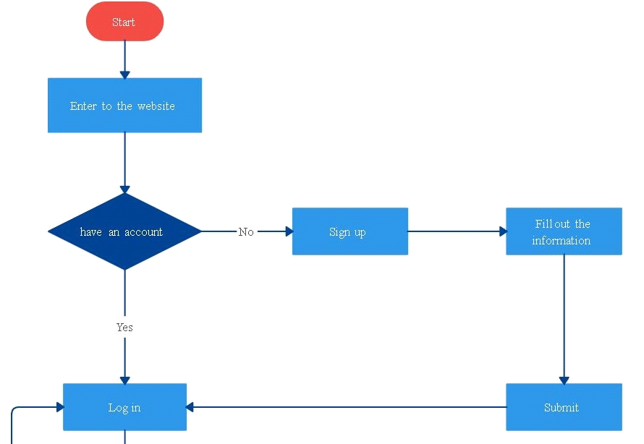

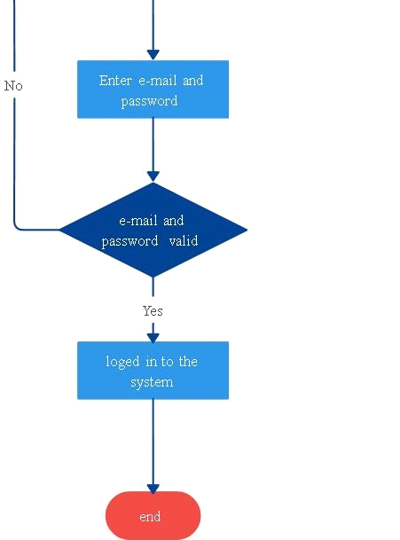

face recognition with song ,age and gender recommendation system

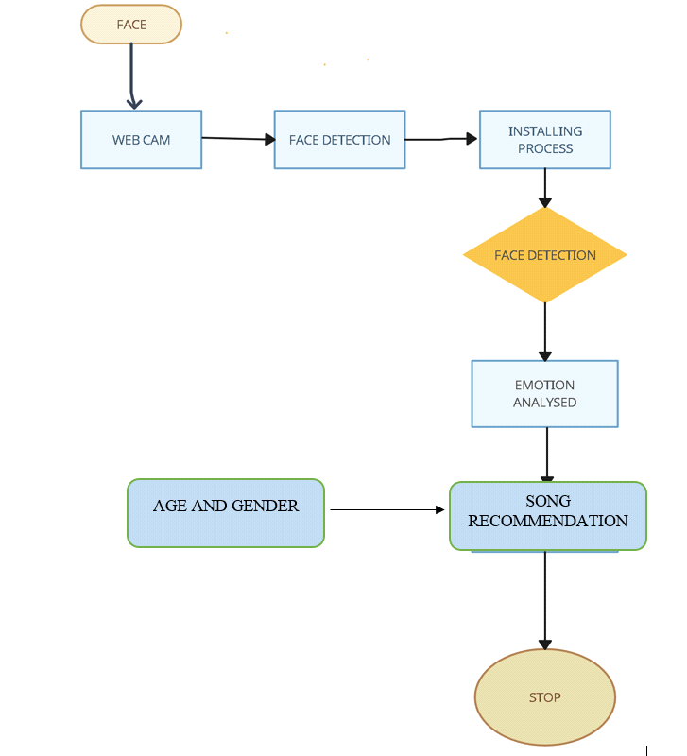

**DATA FLOW DIAGARM:**

* The entire system is projected with a physical diagram which specifics the actual storage parameters that are physically necessary for any database to be stored on to the disk. The overall systems existential idea is derived from this diagram.
* The relation upon the system is structure through a conceptual ER-Diagram, which not only specifics the existential entities but also the standard relations through which the system exists and the cardinalities that are necessary for the system state to continue.
* The content level DFD is provided to have an idea of the functional inputs and outputs that are achieved through the system. The system depicts the input and output standards at the high level of the systems existence.

A DFD does not show a sequence of steps. A DFD only shows what the different process in a system is and what data flows between them.

The following are some DFD symbols used in the project

External entities

DATAFLOW

**RULES FOR DFD:**

* Fix the scope of the system by means of context diagrams.
* Organize the DFD so that the main sequence of the actions reads left to right and top to bottom.
* Identify all inputs and outputs.
* Identify and label each process internal to the system with rounded circles.
* A process is required for all the data transformation and transfers. Therefore, never connect a data store to a data source or the destinations or another data store with just a data flow arrow.
* Do not indicate hardware and ignore control information.
* Make sure the names of the processes accurately convey everything the process is done.
* There must not be unnamed process.
* Indicate external sources and destinations of the data, with squares.
* Number each occurrence of repeated external entities.
* Identify all data flows for each process step, except simple Record retrievals.
* Label data flow on each arrow.
* Use details flow on each arrow.
* Use the details flow arrow to indicate data movements.
* There can’t be unnamed data flow.
* A data flow can’t connect two external entities.

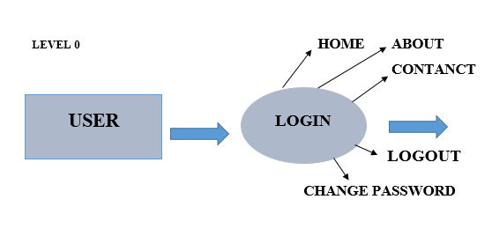

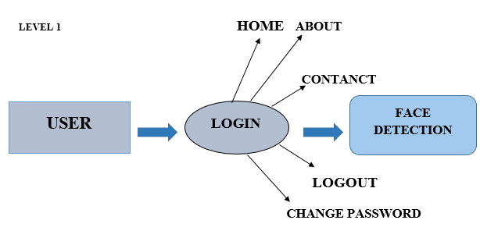

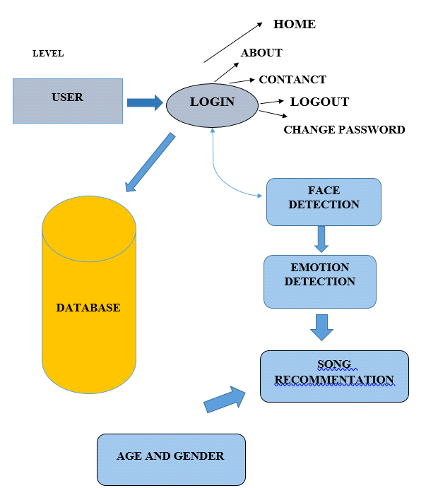

**SYSTEM TESTING AND IMPLEMENTATION**

**5.1 SYSTEM TESTING**

Software testing is a systematic process of evaluating a software application to identify defects, ensure its functionality meets specified requirements, and verify that it behaves as expected. The primary goal of software testing is to deliver a high-quality product that meets user expectations, is reliable, and performs effectively.

The testing process involves executing a software application or system to uncover errors, bugs, or any discrepancies between expected and actual results. It is a crucial phase in the software development life cycle (SDLC) and is conducted at various stages, including unit testing, integration testing, system testing, and acceptance testing.

Unit testing focuses on testing individual components or functions in isolation, ensuring each part of the software works as intended. Integration testing verifies the interactions between different components and identifies issues that may arise during their integration. System testing assesses the overall functionality of the entire system, while acceptance testing determines whether the software meets the user's requirements.

Testing employs various techniques, including manual testing, where testers manually execute test cases, and automated testing, which involves using tools to automate the testing process. Automated testing is particularly beneficial for repetitive tasks, regression testing, and ensuring software stability across different configurations.

Software testing contributes to the production of reliable and robust software by identifying and rectifying defects early in the development process. It helps enhance the software's quality, performance, and security, ultimately ensuring a positive user experience and minimizing the risks associated with software failures.

**SOFTWARE TESTING TECHNIQUES:**

Software testing is a critical element of software quality assurance and represents the ultimate review of specification, designing and coding.

**TESTING OBJECTIVES:**

* Testing is process of executing a program with the intent of finding an error.
* A good test case design is one that has a probability of finding an as yet undiscovered error.
* A successful test is one that uncovers an as yet undiscovered error.

These above objectives imply a dramatic change in view port.

Testing cannot show the absence of defects, it can only show that software errors are present.

There are three types of testing strategie

* Unit test
* Integration test

3. Performance test

**Unit Testing:**

Unit testing focuses verification efforts on the smallest unit of software design module. The unit test is always white box oriented. The tests that occur as part of unit testing are testing the module interface, examining the local data structures, testing the boundary conditions, execution all the independent paths and testing error-handling paths

**Integration Testing:**

Integration testing is a systematic technique or construction the program structure while at the same time conducting tests to uncover errors associated with interfacing. Scope of testing summarizes the specific functional, performance, and internal design characteristics that are to be tested. It employs top-down testing and bottom-up testing methods for this case.

**Performance Testing:**

Timing for both read and update transactions should be gathered to determine whether system functions are being performed in an acceptable timeframe.

**IMPLEMENTATION**

The web application is built using the Flask framework, providing a user-friendly interface with login and signup pages for secure authentication. Once users successfully log in, they are directed to a dynamic dashboard that incorporates OpenCV for real-time facial emotion recognition. TensorFlow's Keras API is employed to load and run a pre-trained facial emotion detection model. The dashboard identifies a spectrum of emotions, including "Neutral," "Happy," "Sad," "Disgust," "Fear," and "Angry."

Furthermore, the application utilizes MySQL for robust database management, ensuring secure storage of user information such as email, password, phone number, first name, and last name. Flask-SocketIO facilitates real-time communication between the client and server, offering dynamic updates to enhance the user experience.

The backend seamlessly integrates machine learning and computer vision tasks, enabling the application to recommend s based on the identified facial expressions. The TensorFlow library handles machine learning aspects, while OpenCV captures and assesses real-time face photos. This amalgamation of technologies results in an interactive online platform that not only authenticates users securely but also offers personalized song recommendations based on their facial emotions, providing a unique and engaging user experience.

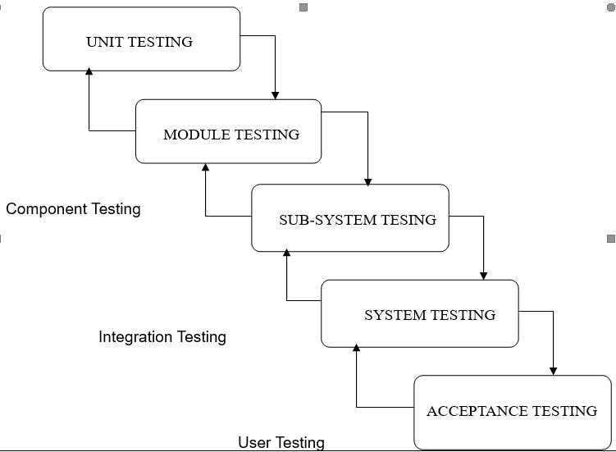

* **DATABASE DESIGN**

**TABLE NAME: LOGIN**

|  |  |  |  |
| --- | --- | --- | --- |
| **S.**  **NO** | **FIELD**  **NAME** | **DATA**  **TYPE** | **CONSTRAINT** |
| 1 | id | Varchar(50) | Primary key |
| 2 | First_name | Varchar(100) | Not Null |
| 3 | Last_name | Varchar(30) | Not Null |
| 4 | Email | Text | Not Null |
| 5 | Password | Varchar(30) | Not null |
| 6 | Phone | Int(10) | Not null |

**RESULT**

**6. RESULT**

The result of this comprehensive web application is an interactive online platform that seamlessly integrates multiple technologies to deliver a captivating user experience. Users start with a secure authentication process through a Flask-based login and signup system, and upon successful login, they are greeted with a dynamic dashboard.

The dashboard, powered by OpenCV and TensorFlow, performs real-time facial emotion recognition, accurately identifying emotions such as "Neutral," "Happy," "Sad," "Disgust," "Fear," and "Angry." This innovative feature sets the stage for personalized recommendations, including song suggestions tailored to the user's detected emotional state

MySQL ensures the secure storage of user data, encompassing essential details like email, password, phone number, first name, and last name. Real-time communication, facilitated by Flask-SocketIO, enhances the user experience through dynamic updates.

With TensorFlow handling machine learning tasks and OpenCV capturing and evaluating face photos in real-time, the application seamlessly marries computer vision and recommendation systems. The end result is a sophisticated yet user-friendly application that not only recognizes and interprets facial expressions but also provides engaging and relevant content suggestions based on the user's emotional state.

**FUTURE WORK**

**FUTURE WORK**

In future work, the web application can be expanded and enhanced in several dimensions. Firstly, additional machine learning models could be integrated to further refine facial emotion recognition accuracy and introduce new features. Continuous training of these models with diverse datasets would contribute to adapting the system to a broader range of users.

Furthermore, the recommendation system can be enriched by incorporating collaborative filtering algorithms or content-based filtering methods, considering user preferences and historical interactions. This can result in more personalized and accurate content suggestions, not limited to songs but potentially encompassing a wider array of entertainment choices.

To bolster security, implementing advanced encryption techniques and incorporating multi-factor authentication can fortify the protection of user data. Regular security audits and compliance with evolving cybersecurity standards are crucial for maintaining user trust.

Moreover, expanding the platform to support multiple languages and internationalizing the content recommendation system can cater to a global audience, enhancing inclusivity and user accessibility.

Finally, user engagement features, such as user reviews, ratings, and social sharing functionalities, can be integrated to foster a community within the application. This community-driven aspect could enhance the overall user experience and create a more vibrant and interactive platform. Continuous user feedback, usability testing, and staying abreast of emerging technologies will be key to ensuring the application remains innovative and meets evolving user expectations.

**BIBLIOGRAPHY**

**7. BIBLIOGRAPHY**

**HTML ,CSS ,JAVASCRIPT**

• Source: <https://developer.mozilla.org/en-US/docs/Web/HTML>

• Source: <https://www.w3schools.com/html/>

• Source :<https://www.w3schools.com/css/>

• Source: <https://developer.mozilla.org/en-US/docs/Web/JavaScript>

**XAMPP**

• Title: XAMPP - Cross-Platform Apache, MySQL, PHP, and Perl

• Source: <https://www.apachefriends.org/index.html>

• Source: <https://www.w3schools.com/php/>

**PYTHON LIBRARYS:**

•NumPy: <https://numpy.org/doc/>

•TensorFlow Keras: <https://www.tensorflow.org/guide/keras>

•Flask: <https://flask.palletsprojects.com/en/2.1.x/>

•OPENCV: <https://docs.opencv.org/>

**DEFAULT MODEL:**

Source: <https://huggingface.co/microsoft/DialoGPT-medium>